Home Learning
Contents

The role of the school; teacher and parent

Guidelines on home learning

Help with Reading at school

Help with Maths

At Stannington Infant School we recognise the fact that parents are the children’s ‘first educators’ and we acknowledge the vital role that parents and families play in a child’s learning. Learning at home is an essential part of good education.

The Role of School

As a school we will endeavour to:-
- Acknowledge the importance of all learning that takes place outside school; including at clubs (Beavers, Rainbows etc) sporting activities, visits and days out.
- Direct and support families in finding appropriate out of school opportunities, especially for those children with specific talents

The Role of the Teachers’ / Teaching Assistants

The staff in school will:-
- Ensure the homework is achievable, stimulating and fun
- Ensure the home learning is well integrated into the ongoing class work
- Ensure that any tasks are well planned and structured to support progression and learning
- Ensure home learning activities match the needs of the children
- Ensure children who are receiving additional work from an intervention do not receive too much homework
The Role of Parents and Carers

We ask for parental support by:-
- Providing a reasonably peaceful place in which their child can do their home learning
- Making it clear that they value home learning
- Encouraging and praising their child
- Sharing the home learning with their child
- Communicating with school regarding any home learning

Guidelines for what home learning will take place

A curriculum planner for each theme outlines the learning that will take place in each area of the curriculum.

Examples of Curriculum Planner. See the website for more examples:

www.stanningtoninfants.co.uk

In Key Stage 1 children will be given between 5 and 10 spellings to practise and learn each week. These are graded as ‘Mild’ and ‘Spicy’. All children are asked to learn Mild spellings and try Spicy if possible. There is then the added challenge of using the words in a sentence. As part of morning work children will also be given practise time. On Friday the children will be tested on the spellings.

Maths home learning will include learning maths facts, for example pairs of numbers that total 10 or multiples of 5. There may also be practical tasks for example learning to measure or finding shapes. As part of morning work children will also be given practise time.

In Foundation stage children are given weekly activities to complete that are linked to the learning for example:-
We are learning all about celebrations. Please can you talk with your child about the different celebrations you experience as a family? Please can you draw pictures or stick in photographs of these celebrations. For example: Christmas, Easter, Birthdays, Diwali, Hanukah, and Thanksgiving. You may also like too scribe some of the comments that your child makes
This week we have been learning all about the story of The Gingerbread Man. Please could you talk with your child about the story and the different characters that the Gingerbread man meets? Please can you then make your own Gingerbread Man? You could bake it, paint it, collage it or draw it.

This week we have been looking at numbers up to 5. We would love for you to explore what numbers you see in your home environment. Please could you search for different numbers and take photographs or draw pictures of what numbers you can see? e.g numbers on a clock, door numbers.

In addition whole school challenges and projects are sent home

- I Love Reading project in KS1
- Book at Bedtime (whole school)
- Focus week activities as appropriate e.g. Science Week activities
- Holiday challenges linked to themes (sent out week before the end of the half term) Purplemash will be used as part of these challenges.

We also send home Knowledge Builders which aim to give you the key facts and vocabulary your child will be learning as part of a theme. We hope that this will enable you to support this learning at home through discussion.

Help with Reading at Home

Reading with a child is an important way in which parents can benefit their child’s education. Parents in their own homes can make learning to read an intimate and happy experience, in an atmosphere that we cannot hope to reproduce in a classroom full of children and one adult.

There are many different ways of approaching reading:-

- Reading to your child.
- Reading together with your child (paired reading).
- Listening to your child read.
- You read a section to your child then they read the same section to you.
- Taking it in turns to read.
- The child reads to various members of the family.

It is important to look upon reading as an enjoyable process, an opening into the world of books, (fiction and non-fiction), not a ladder to get from one level to another in reading scheme.

Decoding of words is not the only reading skill, fluency and expression, are equally important. Children should also be able to predict what might happen next, understand the meaning of new words and be able to retell a story. It is very important that children understand what they have read and comprehension skills are an intricate part of the English SATs.

If a child makes a mistake, or gets stuck on a word when they are reading, there are many ways in which you can help them. It is not a good idea to concentrate only upon the letter sounds when there are other clues which could help your child get the word right. The ideas, over the page, should help your child to use a wider range of approaches.

You can prompt them by saying –
- Can you guess what this word might be?
- What would fit in here?
- What would make sense here?
- Have another look at this first letter?
- Something didn’t make sense then, try it again.

You can give extra help by saying –
- Let’s miss it out and come back to it later.
- Go back to the start of the sentence and have another go.
- How does the word begin? Now have another guess?
- Look at the picture, is that any help?
- Have another guess.

Check your child’s guess by asking them –
- Does that make sense?
- Does it sound right?

Tell them how they are getting on by saying –
- You really tried hard to work that one out.
- Yes it is a hard word!
- How did you work out that hard word?
- What clues did you use?
- Well done! You realised that bit didn’t make sense.

Each year we have an ‘I Love Reading’ project and a ‘Book at Bedtime’ month. Please support your child’s progress in reading by taking an active part in these projects.

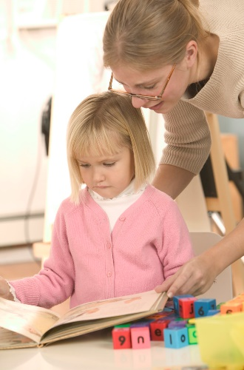

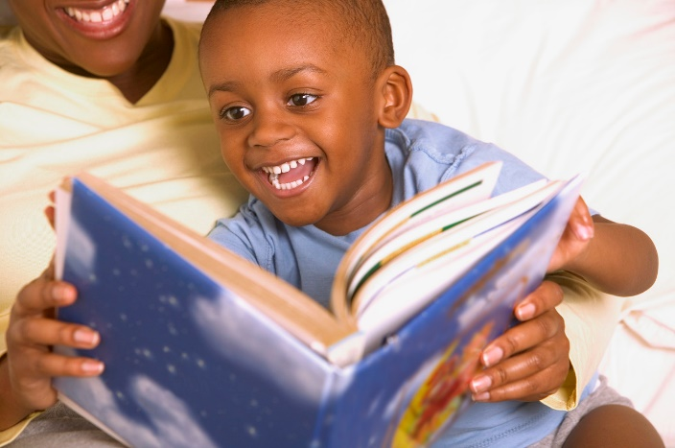

Help with Maths

In addition to the termly maths activity there are many opportunities to support mathematical understanding everyday. The ideas below are based on the principles of using everyday activities to support mathematical understanding. They don’t require any special equipment or lots of recording.

Counting
- Ask him/her to count out 3 forks / knives etc for tea.
- Ask him/her to fetch 2 tins of beans when shopping /put 5 potatoes in a bag.
- Count the stairs to bed each night – this can progress to counting in 2s, 5s and 10s.
- Play games like snakes and ladders.

Children need to see and hear you counting, make deliberate mistakes for them to correct!

1 2 3 4 5 6 7 8 9 10 1 2 3 4 5 6 7 8 9 10

Number recognition / ordering
- Look at numbers in the environment – houses, buses, in shops, on birthday cards. Tell them the numbers and ask if they can see a 7 etc.
- Play 1 to 10 – try to find a number 1 followed by a number 2..3 etc. If you see a number 4 before you have spotted 3 it doesn’t count.
- Write numbers on cards and cut numbers out of paper / card and order them.

1 2 3 4 5 6 7 8 9 10 1 2 3 4 5 6 7 8 9 10

Writing numbers
- If you are playing a role-play situation there are many opportunities e.g. playing school or shops.
- Make a birthday card for a brother or sister with their age on.
- Write a list for shopping, you write the item they write how many.

1 2 3 4 5 6 7 8 9 10 1 2 3 4 5 6 7 8 9 10

Addition and subtraction

- Shopping is a very natural context e.g. we need 4 apples, I’ve got 3, how many do you need to get?
- Add money to make larger totals e.g. 5p + 2p is?

Children will be at different stages with this. Some may need to count to 5 then 2 more whilst others will start at 5 and count on 2.

- Concentrate on the language e.g. what is 1 more than / less than ___? How many altogether? Count on.. back..
- Why not chalk a number track on the ground and play a game using the language.

1 | 2 | 3 | 4 | 5 | 6 | 7 | 8 | 9 | 10
Jump on number 2. Count on 3.
Where are you?
So 2 and 3 makes 5.

Find number 8.
What is 1 more than 8?
What number comes before 8?

Multiplication and Division

- Children need to see multiplication as repeated addition. E.g. counting in 2s is 2 + 2 + 2 etc.
- Using things like pairs is a good way to introduce this.
- Count pairs of socks / gloves in 2s.

How many pairs?
How many socks?
So 4 lots of 2 socks makes 8.

2,4,6,8

Time

- Point out different times throughout the day – breakfast /teatime.
- Find out what time favourite TV programme are on and how long they last for.

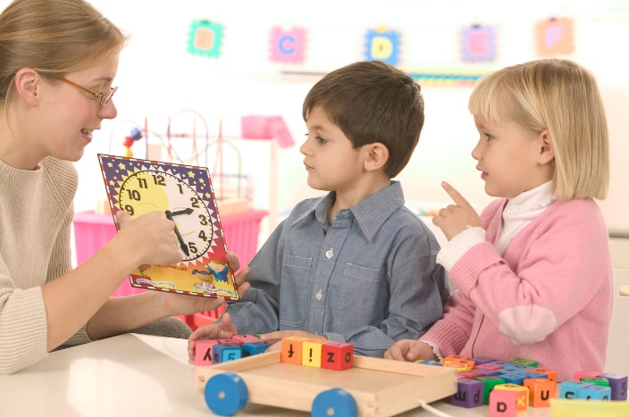

Weight

- Play lighter / heavier. One person thinks of something very light e.g. a feather, the next person has to think of something that would be heavier e.g. an elephant, then it goes back to lighter than an elephant etc.
- Compare the weight of two objects / bags by holding them. Talk about which is heavier / lighter. Introduce a third object – try to order them. Talk about heaviest and lightest.
- Let your children help you weigh out ingredients when baking. Ask questions such as ‘We need 200g of flour, I’ve poured 100g, how much more do we need?’ and ‘We need 100g of chocolate, this is a 400g bar, so how much of it do we need?’

Thank you for taking the time to read this information. We look forward to working with you and your child.

