Stannington Infant School’s
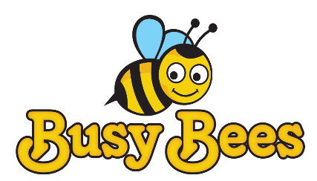
Breakfast and After School Club

Breakfast Club Monday to Friday 7.30 – 8.50am

After School Club Monday to Friday 3.15 – 5.45pm

Stannington Infant School
Stannington Road
Sheffield
S6 6AN

0114 2344401

Email- busybees@stannington.sheffield.sch.uk
Welcome to Stannington Infant School Busy Bees Breakfast and After School Club

Our aim is to provide excellent wrap around provision within a safe and happy environment.

Stannington Infant School offers their own before school care provision. The sessions are charged at £5 for breakfast club which is open from 7.30 am. Each child will receive a healthy breakfast and a drink with quiet space and activities so they are ready for the start of school. Children will be accompanied to the classroom at 8.40 am ready for registration.

After school club is available from 3.15pm until 5.45pm, the sessions are charged at £8.50. The children will have access to both indoor and outdoor facilities, making use of our wonderful school grounds. Indoor activities include craft, colouring and baking; whilst outdoors children will have balance bikes, gardening or sporting fun. A healthy snack will be available e.g. fruit or vegetables, toast, smoothies or milk.

The school building is locked at 6pm. All children must be collected by 5.45pm. If a child is collected after this time then charges will be applied

Our staff are DBS checked and have first aid, food hygiene and safeguarding training. Our Play Leader is Mr Rist and our Play worker is Mrs Palmer.

All bookings must be made one week prior to the date. All bookings must be paid for unless they are cancelled one week in advance.

To book or cancel a place please email
busybees@stannington.sheffield.sch.uk
We have 20 places and cannot accommodate more children at this time. Places will only be allocated upon receipt of the registration form.
Parents/ carers must inform the club if someone other than a parent is collecting your child.

Please pay weekly through ParentMail – invoices will be sent every Monday. Payment must be made in full within 2 days of receiving the invoice. The club reserves the right not to provide childcare if payments are overdue.

Children must be registered with the club in order to access child care. A registration and medical form must be completed and a contract must be signed in advance. The staff will have copies of your registration form and medical form for use in emergencies. These will be stored securely in an area where it is easily accessible for staff.

This provision is registered under the school so when you notify the tax credits of your childcare provision you need to use the school’s OFSTED registration number. If you wish to use childcare vouchers through your employer’s HR then you need to give them the following details:

Stannington Infant School
Stannington Road
Stannington
Sheffield
S6 6AN

OFSTED No: 146510 DFE No: 2294 LEA No: 373

Any queries please contact school on
busybees@stannington.sheffield.sch.uk

