Stannington Infant School

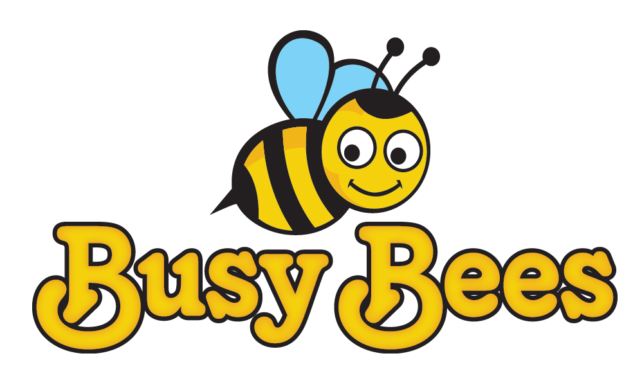
Breakfast & After School Club
Booking Form
Child’s Full Name: |  | Class:
Please tick the days/sessions you require each week or the box to say you will notify school when known if they vary week to week:
Monday
Tuesday
Wednesday
Thursday
Friday
The sessions required are not fixed. I will notify School no later than the Friday of the week prior to my required booking. |  |  |  | Yes

If you have regular booked sessions you need only inform staff of any changes. Please note that the Club reserves the right to charge you for booked sessions which have not been cancelled.

Irregular/Occasional Attendance
If you require different days/sessions each week or only occasional use, please book your child in no later than Friday of the week before via email on busybees@stannington.sheffield.sch.uk Please do not bring your child to breakfast club if you are not booked in. This could affect our staffing ratio and we may not be able to admit them.
Payment
Please pay weekly through ParentMail – invoices will be sent every Monday. Payment must be made in full within 2 days of receiving the invoice. The club reserves the right not to provide childcare if payments are overdue. All cancellations of booked sessions must be given 24 hours in advance otherwise school will reserve the right to charge for these sessions.

Please return this form to the school office as soon as possible. If you have any questions please feel free to contact us on 2344401 or email busybees@stannington.sheffield.sch.uk

