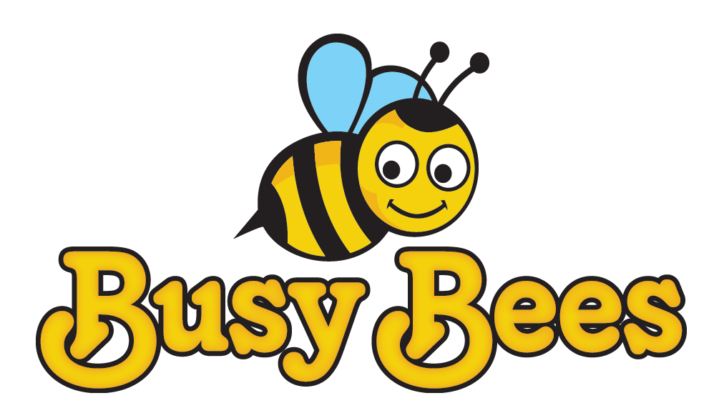 | Stannington Infant School  Breakfast & After School Club  Parent/Carer’s Contract | 

Child’s Full Name: |  | Class:
Parent/Carer Name:

- I understand that Stannington Infant’s Breakfast & After School Club is a playcare facility and that whilst my child is there, the staff are legally responsible for him/her.
- I understand that Stannington Infant’s Breakfast & After School Club opens at 7.30 am. Staff will not be available to supervise my child before this time.
- My child will be provided with breakfast and a drink whilst at the club unless otherwise requested.
- My child will be given stimulating and challenging play opportunities in a fun and safe environment.
- Once my child is delivered in person by a parent or carer to Stannington Infant’s Breakfast Club he/she will be in the care of the staff until they are accompanied to the classroom at 8.50 am.
- I will collect my child from After School Club no later than 5.45pm. Children will be collected from classrooms at 3.20pm and brought to the club by a member of staff.
- I understand that later collection (after 5.45pm) will incur an additional charge
- I will inform the person in charge or the school office if my child will not be attending on a day that he/she is booked in to the club.
- I accept that I will be charged for booked sessions that my child does not attend if I do not contact school to cancel.
- I will book into the club on a weekly basis and will pay on Monday of the following week for sessions within 2 days of receiving the invoice.
- It is my responsibility to keep the staff informed of any alterations to information regarding my child.
- Whilst we try to ensure the safety and security of items we cannot be held responsible for anything lost or stolen.
- I am aware of the school behaviour policy and agree to its terms. If there are major issues with my child’s behaviour they will be discussed with my child and myself. I understand that if their behaviour does not improve my child may not be allowed to attend.
- Should there be any incidents at Stannington Infant’s Breakfast & After School Club involving my child then I will be informed of the situation.
- If my child has an accident then he/she will be treated by a qualified first aider and I will be informed of the situation as soon as possible. In cases of serious injury an accident form will be completed and parent/carer will be asked to sign this form to show they are aware of this injury.
- If there is a situation where my child needs urgent medical treatment and I am unavailable the member of staff from Stannington Infant’s Breakfast & After School Club may sign any consent forms necessary for treatment on my behalf.
- Any information and details regarding my child will be treated as confidential. However, there may be times for example in cases of child protection concerns, when details of my child may be passed on to other agencies. For example, Police, Social Services, and Health Care Professionals.
- Where the club has endorsed my claim for Childcare Tax Credit Stannington Infant’s Breakfast & After School Club are legally obliged to notify the Inland Revenue if I cease to use the service during the period of my claim unless I give a minimum of 10 days notice. Reference to your Tax Credit Claim form will indicate we may be held jointly liable for any claim the Inland Revenue consider to be fraudulent.
- I will pay a retainer for any session booked which my child does not attend at the full amount of Childcare Tax Credit awarded during the period of the claim.
I have read and understood the above terms and conditions and I agree to abide by them.

Signature: ________________________________________

Print Name: ______________________________________

Date: ___________________________

