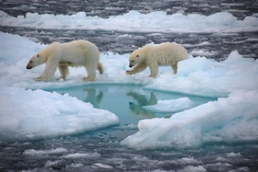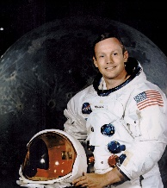

Y1 Topic: Our Changing World Knowledge builder

Key Geography Vocabulary:

Maps – they are a drawing of the Earth’s surface from above, an aerial view. They help us to know where places are located. They have different features like rivers, forests, buildings and roads.

Physical features – these describe the natural environment. These include rivers, hills, forests, mountains, beaches, the weather, soil, vegetation, the sea and cliffs.

Human features – these are man-made. These include a village, city, farm, office, town, shop, house and harbour.

Continents – Our Earth is divided up into seven large pieces of land called **continents**. The seven continents are Africa, Antarctica, Australia, Europe, Asia, South America and North America.

Country – this is a piece of land within a continent.

City – this is a place where people live closely together.

Polar Regions

Neil Armstrong was the very first astronaut to walk on the moon.

History - key vocabulary and people:

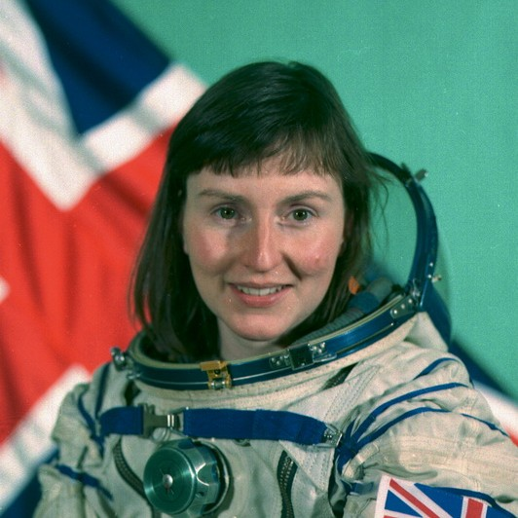

**Chronological Order** – A way of arranging actions, events or things according to the time they occurred.

**Timeline** – A line that shows the order in which related events happened.

**Sequence of events** – The time order in which something of importance takes place.

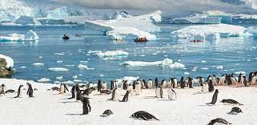

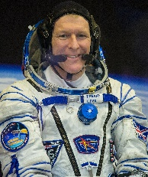

Tim Peake was the first official astronaut to walk in space.

Space

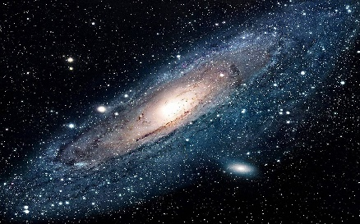

Antarctic

Helen Sharman was the first British astronaut to travel to space.

World map

Positional language:

opposite next to above far near left right

North South East West

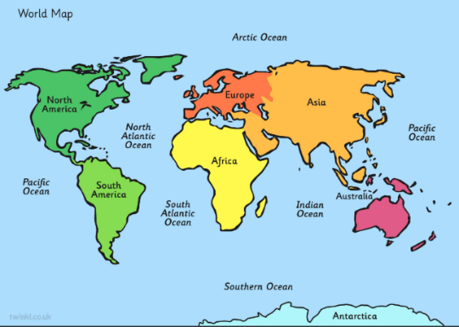

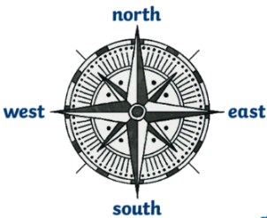

We use a compass to navigate direction.