Stannington Infant School
Reading at Home
Information for Families 2021-22 updated Spring 2022

Which books will my child read as their reading develops at Stannington Infant School?
When children start to learn to read and are accessing the Read Write Inc. phonics programme they will bring three books home:
- A Read Write Inc. (RWInc.) phonetically decodable book
- A book for pleasure
- A library book

Each book has a different purpose:
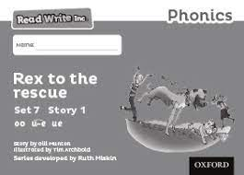
This book is to be read independently by your child.
- Read Write Inc. (RWI) phonetically decodable book (This is where all the words in the book can be sounded out and blended back together.)
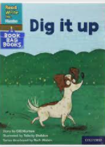
  - When your child is able to blend sounds they will bring home a Read Write Inc. book aligned to the group they are working in for phonics learning. They should be able to decode all the words within this book. This is the type of book they will read to their teacher and TA in class when they are learning to read words. These will usually be a fiction book.
These books are also available online as part of the Oxford Owl Read Write Inc. library. This is your child’s reading book and should be read before the other books.
Your child should read their phonetically decodable book (RWInc.) at least three times a week in order to develop their ability to read words.
The next two books are to be shared with an adult.
- A book for pleasure
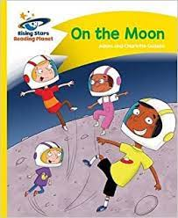
  - These books are to expose your child to High Frequency and Common Exception Words (e.g. said, was) as well as simple comprehension. They may not be able to decode all the words in this book. When that happens please tell your child the word so that they maintain the flow of their reading as these books are intended to help to develop your child’s fluency as well. These will be a mixture of fiction and non- fiction books. These books are also available online as part of the Rising Stars reading library

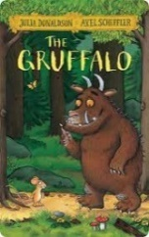
- A library book
- Up to three times a half term your child will bring home a book from our school library. This will be a book for you to enjoy together; to read for pleasure. This book will contain words your child will not be able to read but remember this is for reading together and to enjoy purely as a book. The purpose is to promote excitement and a love of reading. A new book will only be issued when the previous one is returned.
Read Write Inc. (RWInc.) and the book for pleasure need to be returned to school on Monday and Thursday mornings before a new one will be given to your child.
When children have completed the Read Write Inc. phonics programme they will bring home two books:
- A book for pleasure
- A library book

Each book has a different purpose:
- A book for pleasure
  - This book will enable children to practise fluency and comprehension skills and should be read independently to an adult at home and in school. This will now be their reading book.

- A library book
  - This book should be shared with an adult at home but can be read by the child if they are able to. The genres should include fiction, non-fiction and poetry. The focus is to develop fluency, language comprehension and enjoyment.
Once a child is reading beyond lime books in the reading for pleasure system and is a fluent reader they will bring one book home:
- A library book

The purpose of this book is:
- A book for pleasure
  - This book can be shared with an adult but should be read by the child. The genres should include fiction, non-fiction and poetry. The focus is to develop fluency, language comprehension and enjoyment.
Below are some ideas for how you can support your child when they bring home a book for pleasure:
Books to Read for Pleasure Activities
Puppets: create puppets of the characters and retell the story.
Comic Strip: draw a section of the story as a comic strip using speech bubbles and thought bubbles to explain the story.
Through the Keyhole: choose a section of the book. Imagine you are peeping through a keyhole and catch a glimpse of what is going on. Draw what you see.
Write your Own: Write your own story using ideas from the book you have read, changing one of the characters or the problem or where the story is set.
Hot-seating: Dress up as a character or pretend to be the character and ask or answer questions about the story.
Collage: Create a picture of a character from the book using collage.
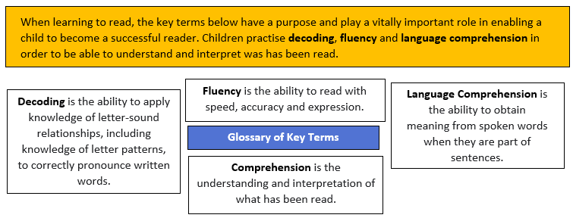
The Read Write Inc. phonetically decodable books and the books for pleasure are both colour coded. The colours are not aligned so your child may bring home a blue Read Write Inc. phonetically decodable book and a turquoise banded book. Your child will bring home a book for pleasure a level below the one they are reading in school in order to practise their fluency
Below are two tables showing the progression through the Read Write Inc. phonetically decodable books programme and the books for pleasure.
Read Write Inc. phonetically decodable books
This is your child’s primary reading book and should be read before other books brought home.
Children’s reading progresses at different rates throughout their time in school and therefore it is important to try and not compare your child with another child. Teaching staff will talk to you about how your child is progressing and where they are in relation to end of year expectations at regular points during the year.
Ditty
Red
Green
Purple | End of Foundation Stage expectations
Pink
Orange
Yellow
Blue | End of Year 1 expectation
Grey
Spelling Programme | End of Year 2 expectation

Books for Pleasure progression once children have completed the Read Write Inc. Phonics programme
Purple
Gold | End of Year 2 expectation for home reading
White
Lime
Beyond Lime

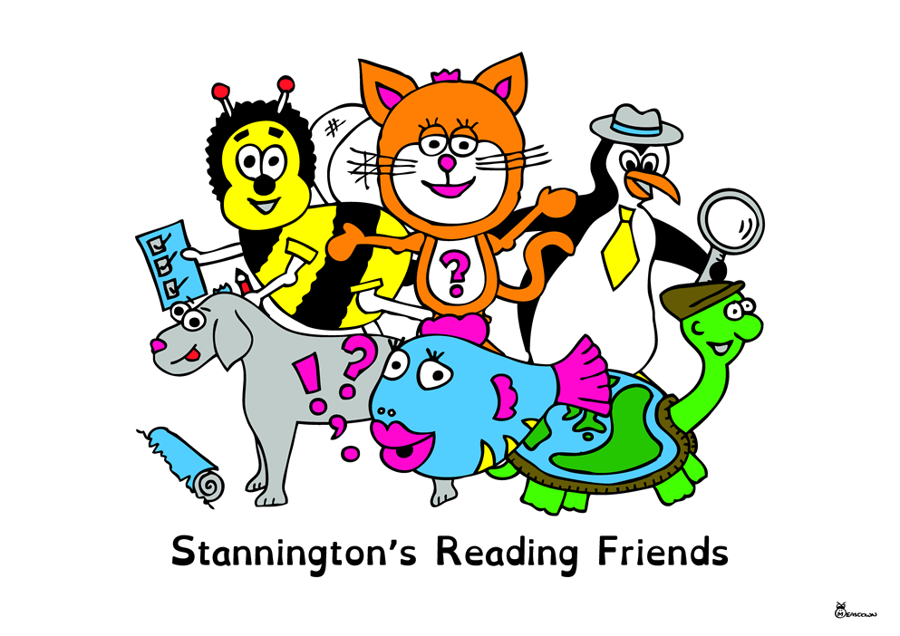
Reading Comprehension
To support children’s understanding and ability to interpret what they have read, a variety of question types are used. The information below gives examples of the different types of questions which may be useful when reading and discussing a book with your child. The questions are grouped using the Stannington Reading Friends characters. Each character has a different focus in reading.
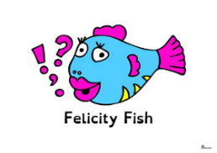
1a: Draw on knowledge of vocabulary to understand texts.
This is Felicity Fish, she likes to talk.
Felicity likes to talk about the words the author uses and tries to help us think of words we could use instead.

- What does this… word/phrase/sentence… tell you about… character/setting etc?
- In the story, 'x' is mentioned a lot. Why?
- The author uses words like … to describe …. What does this tell you about a character or setting?
- What other words/phrases could the author have used?
- The author uses …words/phrases…to describe … How does this make you feel?
- Which words and /or phrases make you think/feel…?

1b: Identify and explain key aspects of fiction and non-fiction texts, such as characters, events, titles and information.
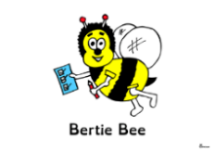  This is Bertie Bee and he is very organised.  Bertie helps us to use the right language to talk about the structure and organisation of a text. | 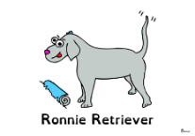  This is Ronnie Retriever  Ronnie helps us to describe, tell and find information in the text.
- How do the title/contents page/chapter headings/glossary/index… help me find information in this book?  - Which part of the text should I use to find…?  - Why has the author organised the information like this? | - Which part of the story best describes the setting?  - What part of the story do you like best?  - What evidence do you have to justify your opinion?  - Find, it. Prove it.  - Where/when does the story take place?  - What did ……. look like?  - Where did …….. live?  - Who are the characters in the book?  - Where in the book would you find…?  - What do you think is happening here?  - What happened in the story?  - What might this mean?

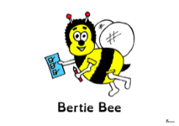
1c: Identify and explain the sequence of events in texts.
This is Bertie Bee and he is very organised.
Bertie helps us to use the right language to talk about the structure and organisation of a text.
- What happens first in the story?
- Use three sentences to describe the beginning, middle and end of this text.
- You’ve got ‘x’ words; sum up this story.
- Sort these sentences/ chapter headings from the story.
- Draw a picture/timeline to show what happens in different parts of the story.
- Why does the main character do in the middle of the story?
- How do the title/contents page/chapter headings/glossary/index… help me find information in this book?

1d: Make inferences from the text.
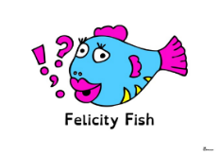  This is Felicity Fish, she likes to talk.  Felicity likes to talk about the words the author uses and tries to help us think of words we could use instead. | This is Percy Penguin, he is like a detective.  Percy helps us to look for similarities and differences in texts and make predictions.
- What makes you think that?
- Which words give you that impression?
- How do you feel about…?
- Can you explain why…?
- I wonder what the author meant.
- I wonder why the author decided to….
- What do these words mean and why do you think the author chose them?

1e: Predict what might happen on the basis of what has been read so far.
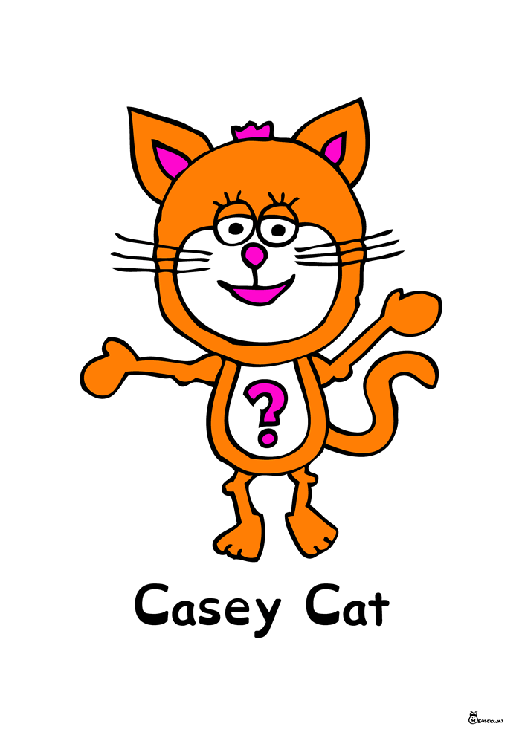  Say hello to Casey Cat. She loves helping us to identify the purpose and genre of the text. She also helps us to work out what the author was trying to achieve and make us think. | Good day to Terry Tortoise.  Terry knows all about traditional stories and helps us to make links to other stories we might have read before. | This is Percy Penguin, he is like a detective.  Percy helps us to look for similarities and differences in texts and make predictions.
- Look at the … What do you think will happen next?
- What do you think will happen to the goodie/baddie/main character? Why do you think this?
- What will happen next? Why do you think this? Are there any clues in the text?
- Can you think of another story which has a similar theme; e.g. good over evil; weak over strong; wise over foolish? Do you think this story will go the same way?
- Which stories have openings like this? Do you think this story will be the same?
- Why did the author choose this setting? How will that affect what happens next?
- How is character ‘x’ like someone you know? Do you think they will react in the same way?

Reading Diaries
Your child will bring home a reading diary for you to record their reading. Please listen to your child read at least three times a week. Please record the title of the book, the date they read and any comments about how they got on.
Each half term the children will bring their reading diaries into school for their class teacher to look at. Class teachers will acknowledge they have seen the book and let you know which Read Write Inc. phonetically decodable book colour and which book for pleasure colour they are reading. Teachers will also let you know if they no longer need a Read Write Inc. phonetically decodable book.

