### 

**Vocabulary**

**Rainforest –** a forest that has a tropical climate. The weather there is hot and humid with lots of rainfall.

**Continents –**a large area of land. There are 7 continents

**Equator –** a line around the earth equal distance from the North and South pole

**Forest floor –** this is the lowest layer where it is dark, damp and hot.

**Understory –** this layer is below the canopy and has lots of small trees and shrubs

**Canopy –** this layer is located under the emergent layer. Most animals and plants live here due to access to food and shelter

**Emergent –** this is the top layer. It is hot, wet, and windy.

**Deforestation –** the clearing of forests

Rainforests are forests that are found near the equator and receive lots of rainfall each year. Rainforests are full of biodiversity, which means they have a variety of animals and plants that live there. There are two types of rainforests: tropical rainforests and temperate rainforests. Rainforest have 4 layers: the forest floor, the understory, the canopy and the emergent layer. Rainforests cover around 6% of the Earth surface and can be found on every continent except Antarctica.

The biggest rainforest is the Amazon rainforest in South America!

Year 1 Topic: Rainforests

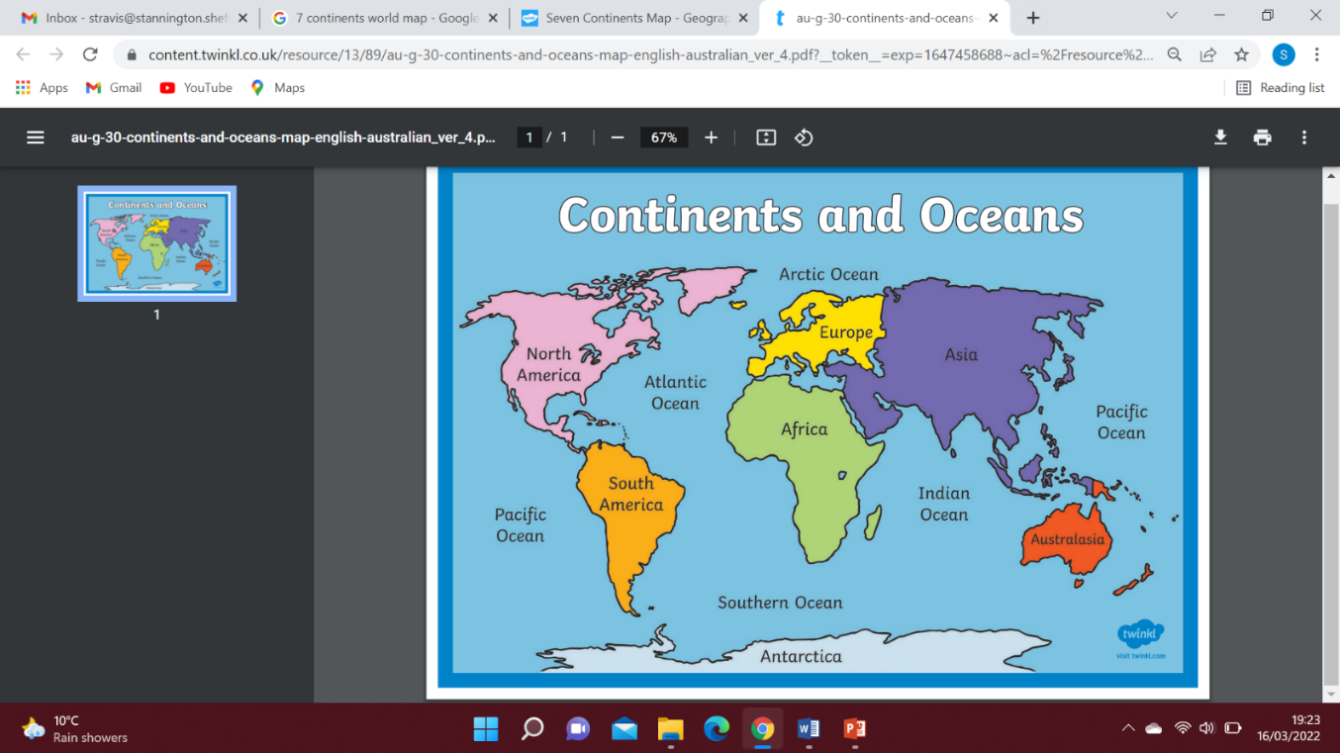

7 continents of the world

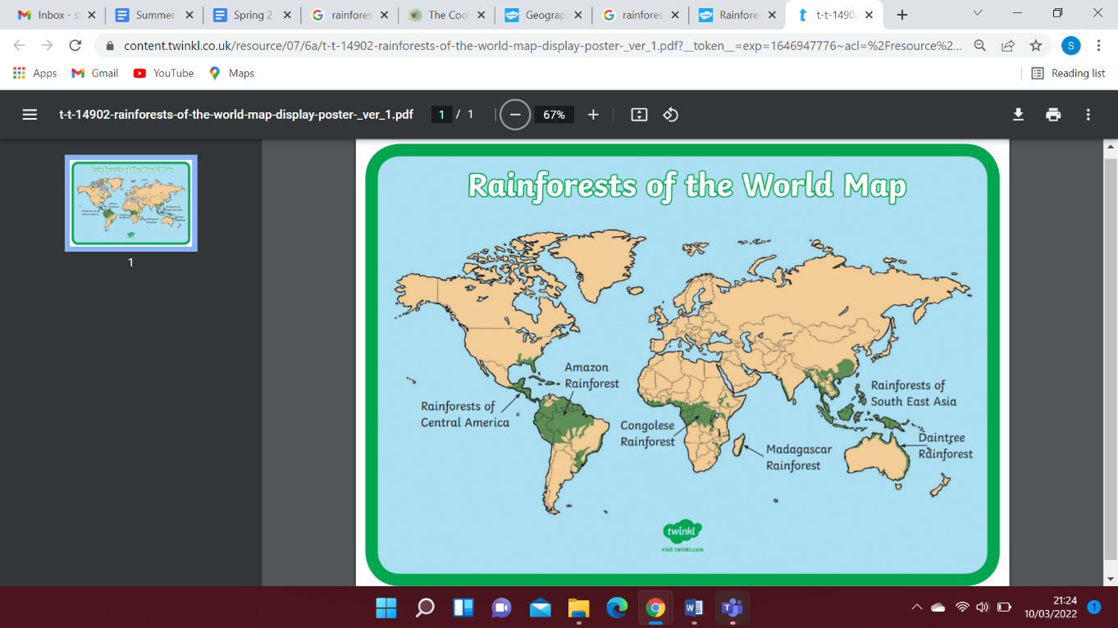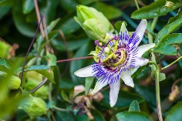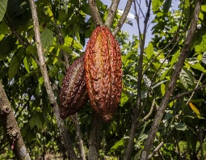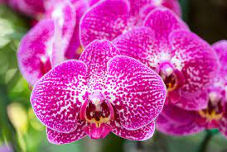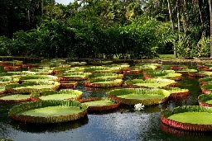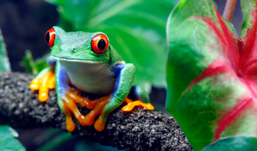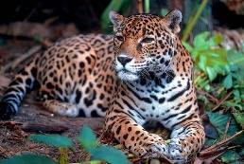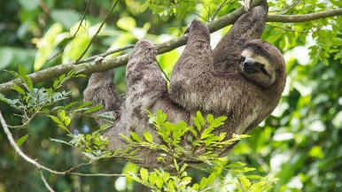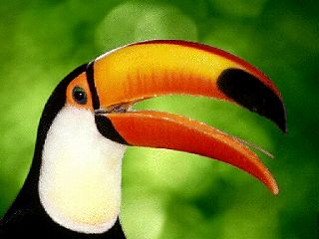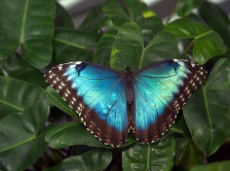

Rainforests of the world

**Can you find out about any other animals and plants found in the Amazon Rainforest?**

**Animals and Plants**

Sloth

Toucan

Butterfly

Leopard

Red-Eyed Tree Frog

Passion Flower

Cacoa Tree

Heliconia Flower (Lobster-Claw)

Orchid

Giant Water Lily