Information Leaflet for
Parents and Carers

How can you help at home?

- Encourage your child to talk about what they are learning – not just in R.E but in all subjects.
- Ask your child questions to encourage them to offer thoughts and opinions.
- During everyday situations which may arise at home, discuss the key concepts of ‘Good and Bad’, ‘Saying sorry’ or ‘Forgiveness’, as well as the importance of rules.
- Point out the different places of worship when you are out and about – in Stannington alone we have a Church of England Church, a Unitarian Church
and a Methodist Church!
- Try to point out other places of worship that your child may be less familiar with such as Mosques or Synagogues.

Feel free to contact the following person for any additional information:

Sarah Gore
RE Co-ordinator

Stannington Infant School
Stannington Road
Sheffield
S6 6AN

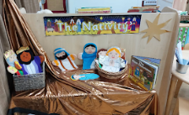

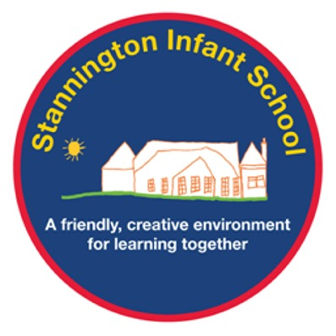

RE at Stannington

RE at Stannington

Why teach RE?

The purpose of this leaflet is to help you understand how R.E is taught at Stannington Infant School.

Foundation Stage

R.E in F.S is taught as part of the specific area ‘Understanding the World’. It is used to help strengthen the positive impressions that children have of their own culture, community and/or faith as well as that of other cultures or faiths within their community. At this stage R.E is taught through stories, as well as festivals that are relevant at specific times of the year, e.g. Diwali and Christmas. This structure provides scope for lots of questioning and discussion, developing skills that can be transferred to other areas of the F.S curriculum, such as Communication and Language. Very often these sessions will naturally direct teaching to include other curriculum areas such as Expressive Arts and Design (e.g. making Diva lamps from clay) and Literacy (e.g. writing their own questions or answers). Children will visit Christ Church and listen to Bible Stories.

Key Stage 1

As children move into Y1 and throughout Y2 we follow the learning objectives set out in the National Curriculum for teaching R.E.
R.E is frequently linked to other areas in the K.S 1 curriculum such as Literacy, PSHE, Art/Drama. The children will now revisit the themes introduced in F.S, however they will now deepen their understanding of the different religions found in their community, linking them to their own experiences and ideas. They will be encouraged to think critically about quite deep religious concepts: Good vs Evil; Right and Wrong; The importance of being sorry; Forgiveness. Once again these themes will be taught linked to stories and festivals. Teaching will also be supported by assemblies that will take place throughout the year and visits to Christ Church (Y1) and the Madina Mosque (Y2). These assemblies and visits will allow the children to explore first-hand the different religions/beliefs that are found in their local community as well as world-wide and help to make their learning more relevant.

The whole school will focus on one key religion each half term and all the R.E units will cover knowledge, understanding and provide time for reflection. All the R.E topics will link with each other as well as to the whole school curriculum, ensuring progression in the subject as the children move through school.

The teaching of R.E encourages children to develop their self-awareness and ability to see how they fit into their community and the world around them. It enables them to see how these different beliefs hold people and communities together and how the rules we follow as a school or in life in general are often based on religious ideas and concepts. It encourages children to talk about their own experiences and feelings and to make links with other individuals and groups. It enhances their communication and listening skills as well as their ability to empathise. This helps to build respect for themselves and others.

