

July2023

**Welcome to the Monthly Bulletin**

The next issue will be out in September

**Health Week 10th to 14th July –**

**please can children come in sports wear all week.**

Monday 10th July **Dance workshops**

Tuesday 11th July **Multi skills sessions**

Thursday 13th July **Circus skills** for Y2 (am)

Thursday 13th July **Sports Day**:- 9.30am FS children / 10.30am Y1 children / 1.30pm Y2 children

Families welcome to come to sports day sessions.

We will also be covering the importance of sleep, hygiene, healthy eating and mental health and well-being.







**Stannington Infant School’s**



**Breakfast and After School Club**

**We are almost full for September – please let us know ASAP if you require a place**

**To book a place please email**

[busybees@stannington.sheffield.sch.uk](mailto:busybees@stannington.sheffield.sch.uk)

**Diary Dates**

3.7.23 Bradfield Secondary students music assembly

5.7.23 Recorder assembly – class 3 at 2.45pm (parents invited)

5.7.23 Y1 Curriculum Evening 6 - 7pm – for parents of current FS children

6.7.23 Y2 Curriculum Evening 6 - 7pm – for parents of current Y1 children

6.7.23 New FS children visit school

6.7.23 Reports sent home

10.7.23 parents informed of classes for the following year.

10.7.23 Health Week

12.7.23 Y1 children singing for families at 3pm

13.7.23 Sports day

14.7.23 PFA Coffee morning & uniform shop 9am

17.7.23 Piano concert (tbc by Pav)

18.7.23 New class visit

20.7.23 Non uniform day – Animal dress up

20.7.23 New Class visit

21.7.23 Leavers assembly 2pm – We are restricted to 1 person per Y2 child due to space.

**Autumn term**

School starts 5.9.23

7.9.23 Come and see the class session 3.20pm – 4pm

11.9.23 Come and see the class session 3.20pm – 4pm

5.10.23 Individual photos

17.10.23 Parents evening

19.10.23 Parents evening

20.10.23 Inset day – school closed to pupils

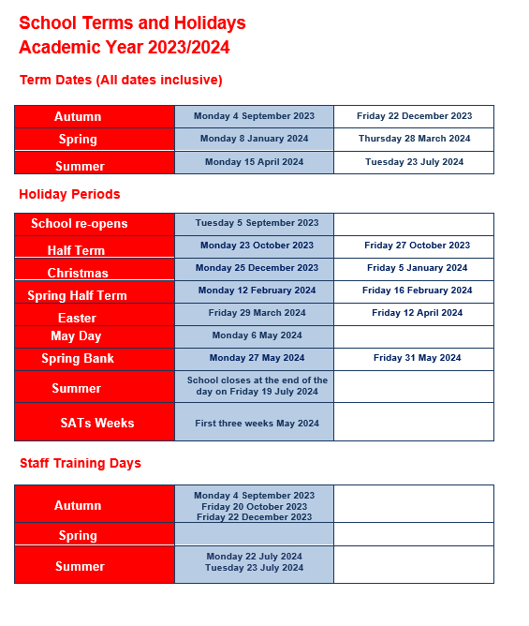

**Contact us ……. Stannington Infant SchoolStannington Road, Sheffield, S6 6AN**

**Telephone: 0114 2344401 Headteacher: Sarah Binns**

**Fax: 0114 2334724 Deputy Headteacher: Liz Harris**

**Email:** [**enquiries@stannington.sheffield.sch.uk**](mailto:enquiries@stannington.sheffield.sch.uk) **Chair of Governors: Elizabeth Tunnard**

**Website: www.stanningtoninfants.co.uk**