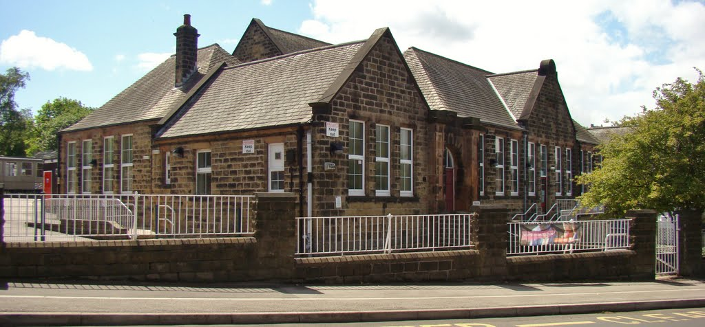

June 2023

**Welcome to the Monthly Bulletin**

The next issue will be out in July

**Health Week 10th to 14th July – please can children come in sports wear all week.**

Monday 10th July Dance workshops

Tuesday 11th July Multi skills sessions

Thursday 13th July Circus skills for Y2 (am)

Thursday 13th July Sports Day:- 9.30am FS children / 10.30am Y1 children / 1.30pm Y2 children

We will also be covering the importance of sleep, hygiene, healthy eating and mental health and well-being.

**Art Showcase**

Thursday 15th June

3.30pm to 4.30pm

We would like to invite all families to come and see the art work your child has been doing over the last two weeks as part of our focus weeks.

Each child’s books will be available in the classroom as well as the printing and clay work they have been making.

Items will be available for sale at the Summer Fayre on Saturday 24th June

Individual and uniquely designed T-shirts will be £3.00 and clay pots £1.00

We will also have an Art trail for each child to take part in - children will bring answer sheets home on Thursday 15th. Questions will be in the school grounds for the children to answer. Completed sheets will need to be returned to class by Monday 19th to be entered into a prize draw.

In addition to this, there will be a number of ‘search and discover art around the world’ pictures in the trim trail for families to enjoy.

We really hope you will be able to join us.

**Diary Dates**

5.6.23 Inset day

7.6.23 Stannington Brass Band assembly

9.6.23 FS hearing tests

12.6.23 Y1 Phonics screening commences

12/13/14.6.23 Mr Payne poetry reading in school

12.6.23 10 Day Challenge – can you travel actively to school every day?

14.7.23 Recorder assembly – class 4 at 2.45pm (parents invited)

15.6.23 Art showcase for parents after school

19.6.23 Art Club presentation (after school)

20.6.23 Y1s to Christchurch

20.6.23 6pm FS welcome meeting for Sept 2023 starters

22.6.23 Active travel breakfast – please return reply slip to request a breakfast

2.6.23 Wonderdome in school for Y1s NEW DATE

24.6.23 **PFA summer Fayre** – please put this in your diary now. We will need lots of help on the day!!

27.6.23 Class 5 ukulele concert at 2.30pm (parents invited)

3.7.23 Bradfield Secondary students music assembly

5.7.23 Recorder assembly – class 3 at 2.45pm (parents invited)

5.7.23 Y1 Curriculum Evening 6 - 7pm – for parents of current FS children

6.7.23 Y2 Curriculum Evening 6 - 7pm – for parents of current Y1 children

10.7.23 Health Week

13.7.23 Sports day

14.7.23 PFA Coffee morning & uniform shop 9am

20.7.23 Y2 celebration event (pm)

21.7.23 Leavers assembly 2pm –We are restricted to 1 person per Y2 child de to space.

**Staffing update for September 2023**

We are now in a position to give you an update on teaching staff for September 2023.

Mrs Fisher will be on maternity leave from September 2023 so we will be welcoming a new teacher, Mrs Alyson Cann to our team. Miss Howell is getting married this summer so will be returning in September as Mrs Starkey.

Mrs Billingsley will be teaching in the Integrated resource so Miss Gore will be leading Foundation Stage.

**Class Teachers will be as follows:-**

Class 1 Miss Gore (full time)

Class 2 Mrs Greensmith (Mon /Tue/Wed) Mrs Birtles (Thu / Fri)

Class 3 Mrs Starkey

Class 4 Miss Travis

Class 5 Mrs Cann

Class 6 Mrs Harris (Mon /Tue/Wed) Mrs Everitt (Thu / Fri)

**Breakfast Club** Monday to Friday 7.30 – 8.50am

[This Photo](https://www.pngall.com/sick-png) by Unknown Author is licensed under [CC BY-NC](https://creativecommons.org/licenses/by-nc/3.0/)

**Stannington Infant School’s**

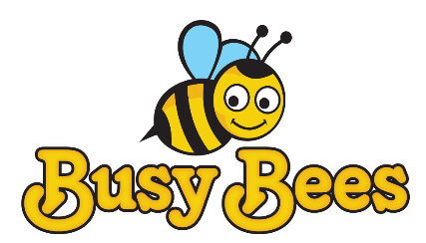

**Breakfast and After School Club**

**After School Club** Monday to Friday 3.15 – 5.45pm

Our aim is to provide excellent wrap around provision within a safe and happy environment.

The sessions are charged at £5 for breakfast club which is open from 7.30 am. Each child will receive a healthy breakfast and a drink with quiet space and activities so they are ready for the start of school. Children will be accompanied to the classroom 8.40 am ready for registration.

After school club is available from 3.15pm until 5.45pm, the sessions are charged at £8.50. The children will have access to both indoor and outdoor facilities, making use of our wonderful school grounds. Indoor activities include craft, colouring, baking, whilst outdoors children will have balance bikes, gardening or sporting fun. A healthy snack will be available e.g. fruit or vegetables, toast, smoothies or milk.

**This half term in Busy Bees your child will have the chance to..**

* **Take part in a sports session lead by a sports coach**
* **Take part in a craft session**
* **Help to look after the school bees**

**To book a place please email**

[busybees@stannington.sheffield.sch.uk](mailto:busybees@stannington.sheffield.sch.uk)

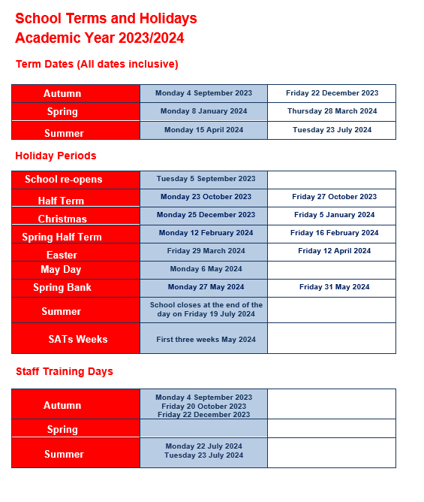

**Contact us ……. Stannington Infant SchoolStannington Road, Sheffield, S6 6AN**

**Telephone: 0114 2344401 Headteacher: Sarah Binns**

**Fax: 0114 2334724 Deputy Headteacher: Liz Harris**

**Email:** [**enquiries@stannington.sheffield.sch.uk**](mailto:enquiries@stannington.sheffield.sch.uk) **Chair of Governors: Elizabeth Tunnard**

**Website: www.stanningtoninfants.co.uk**