May 2023
Welcome to the Monthly Bulletin
The next issue will be out in June

Meet Django, a miniature cocker-poo.
Django lives with Mrs Grayson but will be visiting our school regularly to support the well being and mental health of pupils.
Last week we had a school assembly from the Blue Cross on dog safety and today the children practised this with Django.
There are well documented benefits for the children including engendering a calming effect, fostering a sense of responsibility, developing a love of animals and a confidence around them, to name a few.
Django is a cocker poo, which means he is non-shedding and therefore suitable around children with allergies. He is 2 years old, has an outstanding temperament and has been well trained.
We will be sending a letter of permission to parents if Django is to support individual pupils or have a specific role. All contact will be planned and no child will be left unsupervised with Django. When he is not with the children he will be in one of the school offices. All areas in school are vacuumed and surfaces wiped daily and after working with the dog the children will wash their hands.
If you do not wish your child to interact with Django please email and let us know.
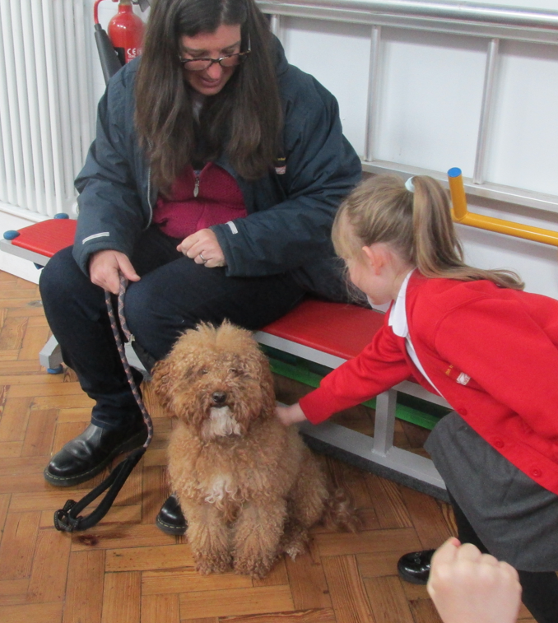

Safety
Please can we ask that ALL parents and carers ensure that children are taken to the classroom door every morning. Whilst we have not experienced an issue thus far we are aware that the potential for a child to go missing is too high a risk to take.
Thank you for your support
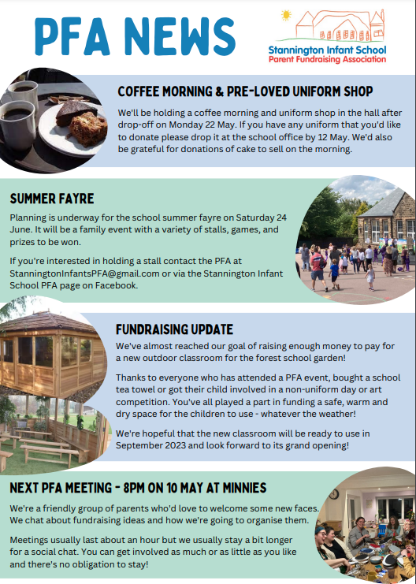

Come and have a coffee with us.

Save the date.
Can you help?

We are very nearly there, please support us to raise the final amount.

A great way to get involved and support school.
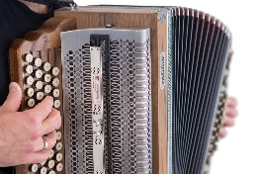
Do you play an instrument? If so we need you!!
We are looking to increase the opportunities children have to hear live music. If you play an instrument we would love it if you would come into school to play for the children.
Please would you get in touch or chat with a teacher if you could help us with this.
Diary Dates
9.5.23 Coronation day in school
11.5.23 Y2 Movefest
16.5.23 Class Photographs – please can everyone wear school uniform, thank you
16.5.23 Class 6 ukulele concert 2.30pm
17.5.23 Book Fair – families can visit after school each day until 4pm.
22.5.23 Arts week in school
22.5..23 PFA Coffee morning & uniform shop 9am
29.5.23 Half Term
5.6.23 Inset day
6.6.23 Wonderdome in school for Y1s
12.6.23 Y1 Phonics screening commences
12/13/14.6.23 Mr Payne poetry reading in school
12.6.23 10 Da Challenge – can you travel actively to school every day?
15.6.23 Art showcase for parents after school
22.6.23 Active travel breakfast
24.6.23 PFA summer Fayre – please put this in your diary now. We will need lots of help on the day!!
27.6.23 Class 5 ukulele concert 2.30pm
10.7.23 Health Week
13.7.23 Sports day
14.7.23 PFA Coffee morning & uniform shop 9am
21.7.23 Leavers assembly 2pm –We are restricted to 1 person per Y2 child de to space.

This Photo by Unknown Author is licensed under CC BY-SA
Breakfast Club Monday to Friday 7.30 – 8.50am
This Photo by Unknown Author is licensed under CC BY-NC
Stannington Infant School’s
Breakfast and After School Club

After School Club Monday to Friday 3.15 – 5.45pm

Our aim is to provide excellent wrap around provision within a safe and happy environment.

The sessions are charged at £5 for breakfast club which is open from 7.30 am. Each child will receive a healthy breakfast and a drink with quiet space and activities so they are ready for the start of school. Children will be accompanied to the classroom 8.40 am ready for registration.
After school club is available from 3.15pm until 5.45pm, the sessions are charged at £8.50. The children will have access to both indoor and outdoor facilities, making use of our wonderful school grounds. Indoor activities include craft, colouring, baking, whilst outdoors children will have balance bikes, gardening or sporting fun. A healthy snack will be available e.g. fruit or vegetables, toast, smoothies or milk.
To book a place please email
busybees@stannington.sheffield.sch.uk
Please note that if you wish for your child to have breakfast please ensure they arrive by 8.15 am.
Thank you
Please can we ask that when dropping off at breakfast club after 7.45am parents park on the road to ensure the car park spaces are available for staff. Thank you

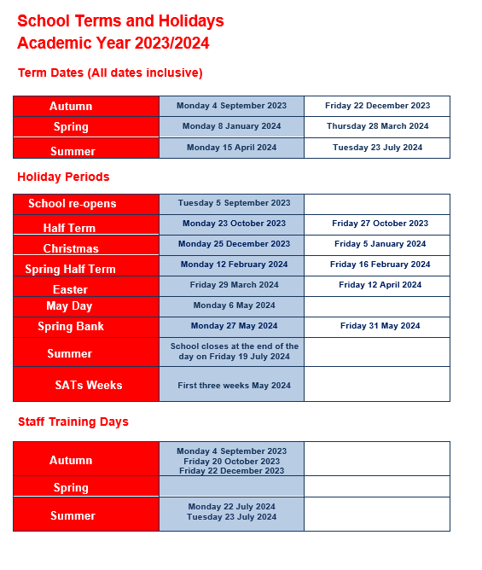
Contact us ……. Stannington Infant SchoolStannington Road, Sheffield, S6 6AN
Telephone: 0114 2344401 Headteacher: Sarah Binns
Fax: 0114 2334724 Deputy Headteacher: Liz Harris
Email: enquiries@stannington.sheffield.sch.uk Chair of Governors: Elizabeth Tunnard
Website: www.stanningtoninfants.co.uk

