
Christmas 2023 at Stannington Infant School
PFA Christmas Fayre 5-7pm School hall.
The children have been busy making their Christmas products to sell.
We’ve got games, stalls, food, the brass band and much more!!!
Tickets are now on sale £1.50 per person. Tickets will also be available on the night for £2.00 per person.
You can also pre book veggie and meat hotdogs in advance so you don’t miss out. £1.50 per hot dog.
There will also be a tuck shop on the night with crisps, raisins, sweets and cold drinks. Plus, a coffee and mulled wine van!
We can’t wait to see you there!
Nativities are at Christchurch Stannington.
FS 10am Monday 4th December
Y1 2pm Monday 4th December
Y2 2pm Tuesday 5th December
Unfortunately, photographs of the performance are not allowed as permission for photography needs to be gained. Photographs can be bought of your child for £1 each.
Please order on the day and pay cash for these.
Maximum 2 adults per child at the performance please.
Christmas Jumper Day 7th December
£1.00 if you are able for Save the Children, thank you.
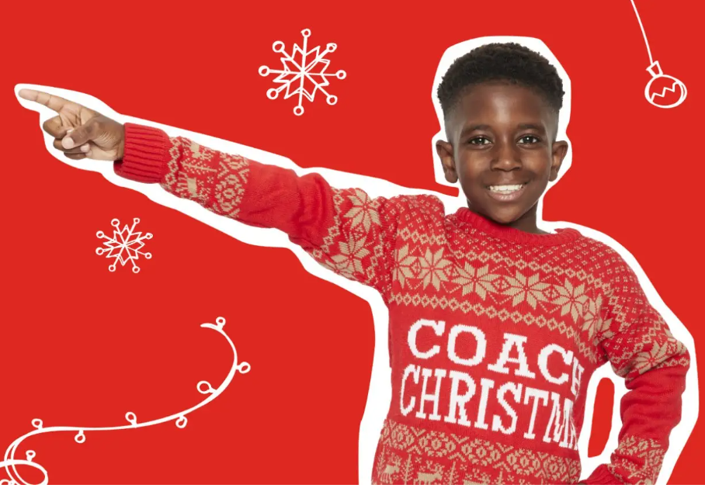
Christmas Party day 15th December
Then Puzzling Paul is coming to amaze us with his magic and Alfie the Elf will give us the latest news from the North Pole.
Many thanks to the PFA for funding this for the children.
Christingle Service
Making Christingles 18th at 9.45am in school; parental help if possible.
Christingle service 10am Christchurch 21st December.
Families welcome
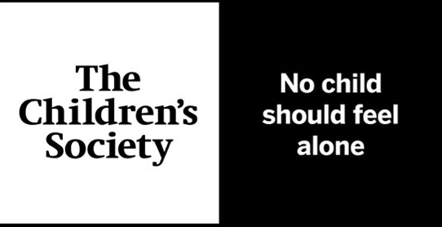
£1.00 if you are able for The Children’s Society, thank you.
Christmas Singing
Don’t forget that on Tuesday 19th at 3.10pm we will be singing
Christmas songs in the playground.
Please do come and join us.
FS on the stage / Y1 outside their classroom / Y2 on the stage.
Christmas Dinner 20th December

Wishing you all a happy Christmas and the very best for 2024

