**Topic: Sheffield**

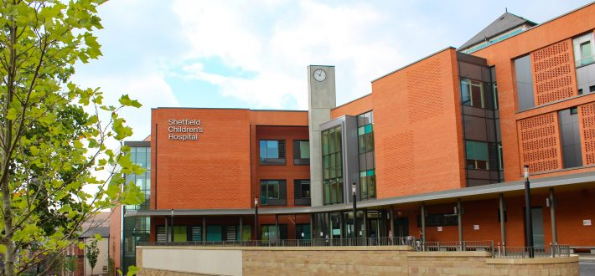

**History Key Vocabulary Chronology: Chronological order** – A way of arranging actions, events or things according to the time they occurred. **Timeline** – A line that shows the order in which related events happened. **Sequence of events** – The time order in which something of importance takes place. **Historical Knowledge: Cause** - why something happened. **Effect** – something that happened because of something else. **Facts** – information that is true. **Famous** – well known. **Recount** – telling someone about an event or experience. **Research** – investigating to find out facts or conclusions. **Source** – Where something comes from or where it can be found.

**KS1 Knowledge Builder**

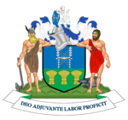

**Florence Nightingale** was the founder of modern nursing. She was a nurse during the reign of Queen Victoria and worked as a manager and trainer of nurses during the Crimean War. **Interesting fact:**At the age of 37 she gave up nursing and spent 11 years in bed!

**Geography Key Vocabulary**

**Area** – part of a town, country or the world.

**Community** – a group of people living in the same place.

**Locate** – to discover the exact place or position of.

**Atlas** - A collection of maps.

**Compare** - To identify the similarities and differences between features or places.

**Compass** - An instrument used for navigation. It shows us **direction** and uses 4 direction points (North, East, South and West).

**Environment** - The surroundings or conditions in which a person, animal, or plant lives.

**Globe** - A spherical model of Earth.

**Human features -** Man-made landmarks, buildings or features that are built by or changed by humans.

**Physical features** - A feature formed by nature, features such as mountains, rivers, deserts and oceans.

**Landmarks** - An object or feature that is easily recognised from a distance. It helps someone to find their location.

**Symbol** - A mark, picture or sign representing a feature on a map.

**Location** - A place or position.

**Rural** - An area in the countryside.

**Costal** – The place where the land and sea meet.

**Urban** - An area in the city.

**Continent** – A huge area of land separated from others by water or natural features. There are 7 continents – Europe, Africa, North America, South America, Asia, Antarctica and Australasia.

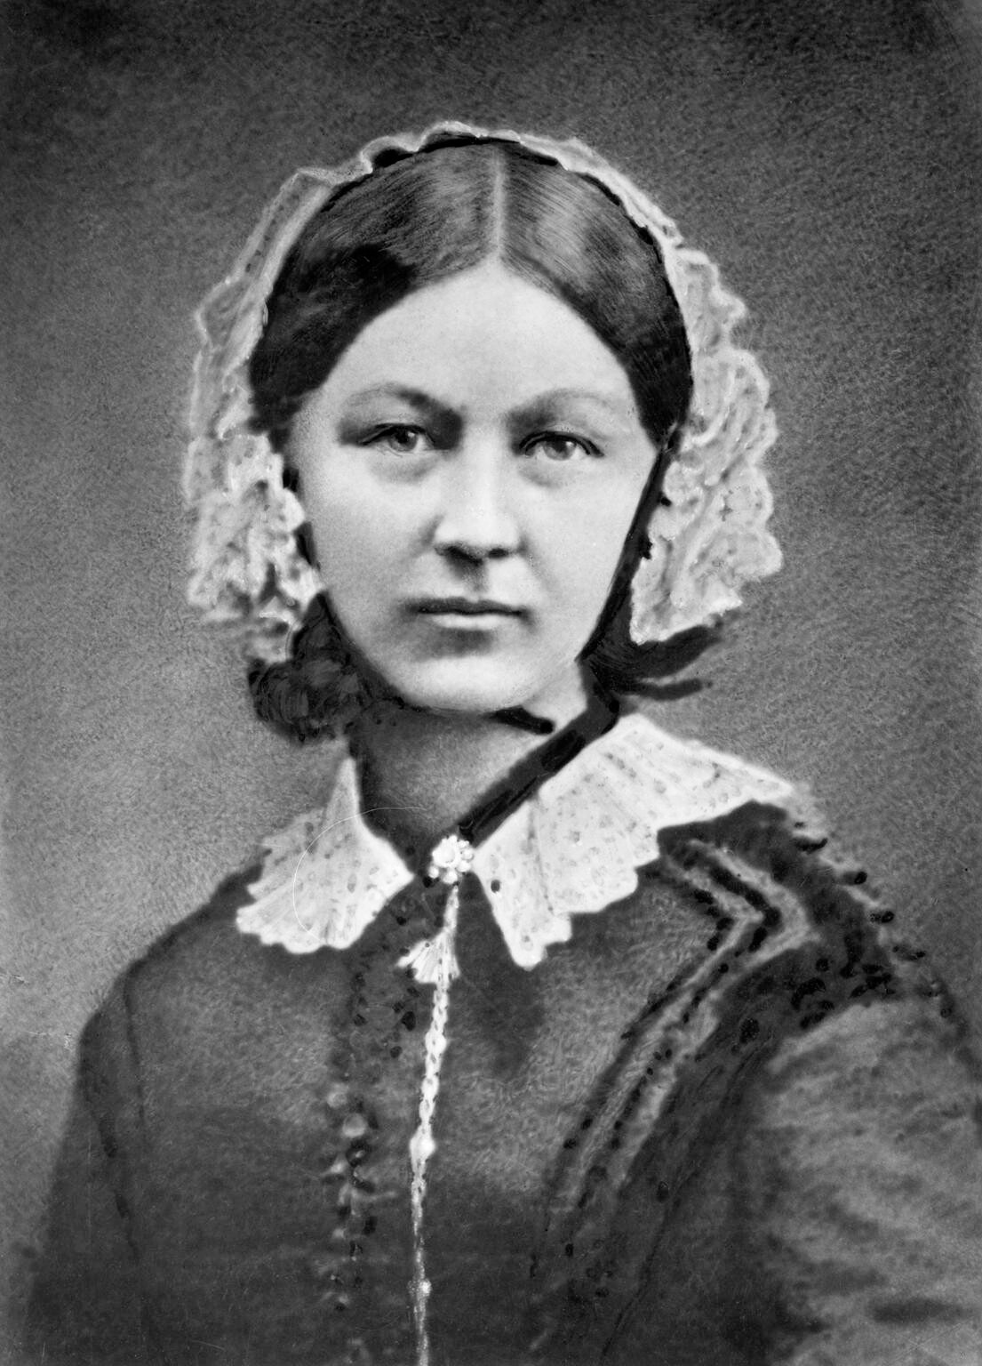

The coast of Cleethorpes is 4 miles long, but the coast of Kenya is 333 miles long!

The capital city of Kenya is Nairobi. It is named after the River Nairobi which flows through the city.

**Did you know that Sheffield is the greenest city in the UK? Look at a map, how can you tell?**

