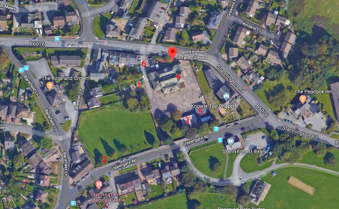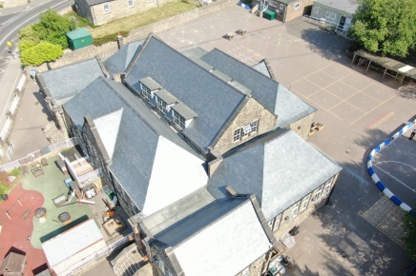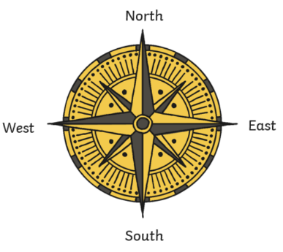

**Key Geography Vocabulary:**

**Maps** – they are a drawing of the Earth’s surface from above, an aerial view. They help us to know where places are located. They have different features like rivers, forests, buildings and roads.

**Physical features** – these describe the natural environment. These include rivers, hills, forests, mountains, beaches, the weather, soil, vegetation, the sea and cliffs.

**Human features** – these are man-made. These include a village, city, farm, office, town, shop, house and harbour.

**Country** – this is a piece of land within a continent.

**City** – this is a place where people live closely together.

**Village** – this a place where people live. It is smaller than a city.

**Local area** – the surrounding area of where you live.

**Ariel view** – a view from above, sometimes called a bird’s eye view.

Y2 Our School - Knowledge Builder

This is a compass. There are 4 direction points North East South West

Naughty Elephants Squirt Water

Do you know your address?

Can you name the city you live in?

Can you name the village where you go to school?

What is similar/different about Stannington & Sheffield?

**Key History Vocabulary:**

**Chronological order** – things that have happened in order.

**Sequence of events** – things that have happened in order

**Timeline** – a line to show the order in which events happened.

**Past** – a time before now.

**Present** – the time right now.

**Cause** – why something has happened.

**Effect** – something that happened because of something else.

**Facts** – information that is true.

**Recount** – telling someone about an event or experience.

**Source** – where something comes from or can be found out about.



**Significant people**:

Did you know that Queen Victoria’s first name was actually Alexandrina?

She was **Queen of Great Britain and Ireland** for 63 years from 1837 – 1901.

Queen Victoria died in 1901.

Did you know Stannington Infant School was built in 1910?

That is over 100 years ago!

The Great Sheffield Flood was a flood that devastated parts of Sheffield, England, on 11 March 1864.

The Dale Dyke Dam broke as its reservoir was being filled for the first time. At least 240 people died and more than 600 houses were damaged or destroyed.